

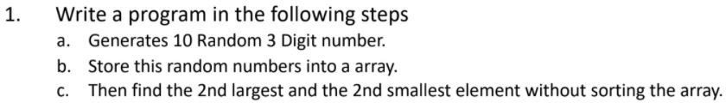

CODE—

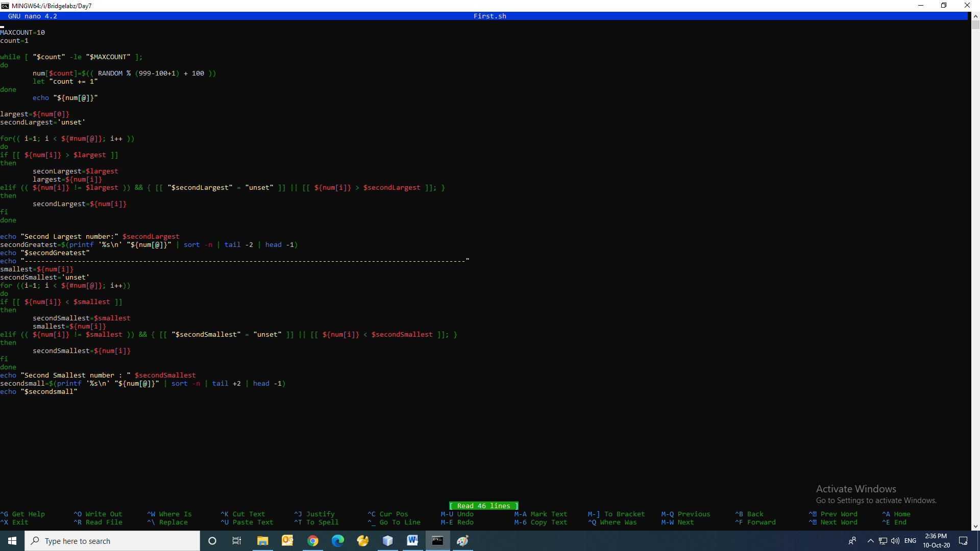

# EXECUTION--

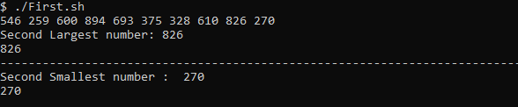





**EXECUTION--**



Note : Question 1 and Question 2 Answer are same.



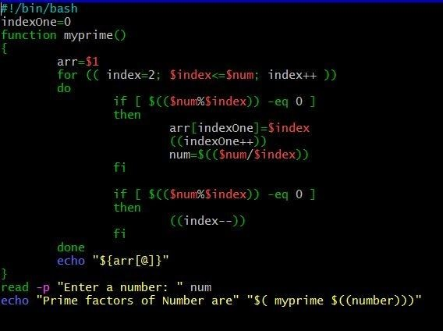

EXECUTION--

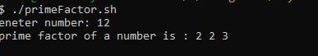



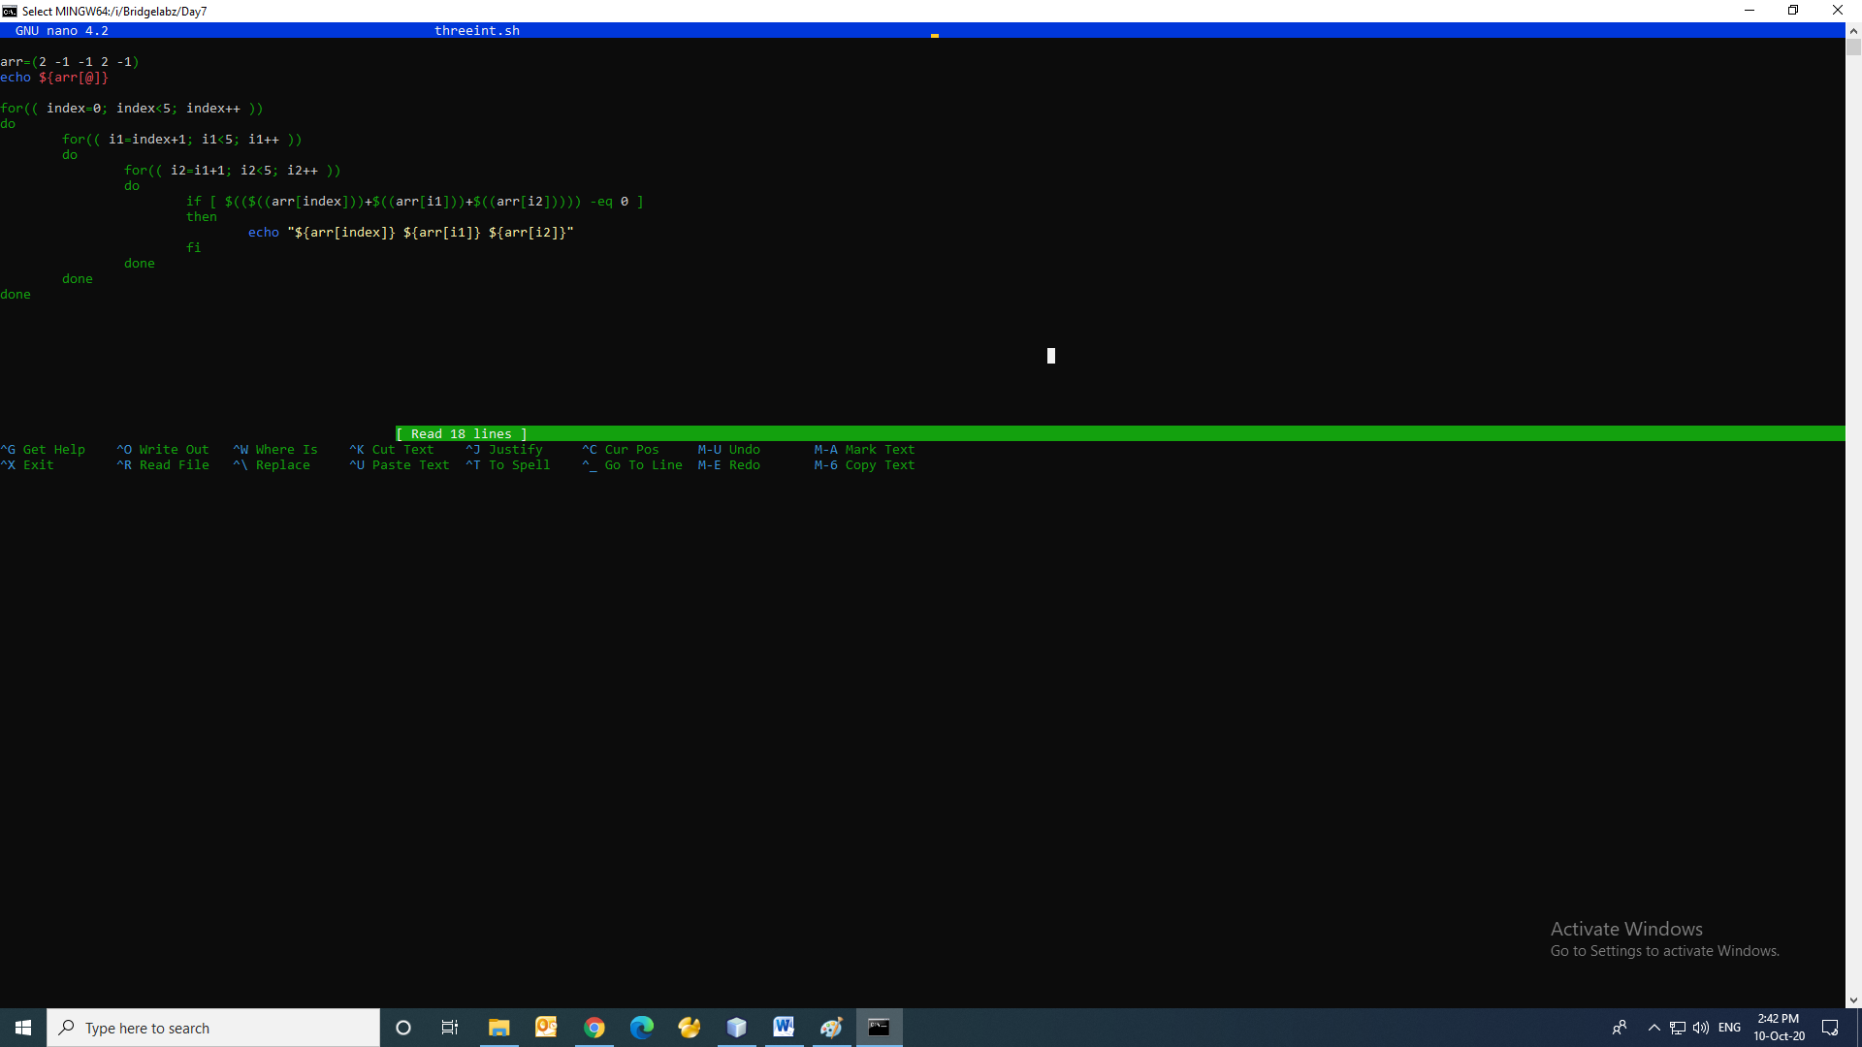

EXECUTION--

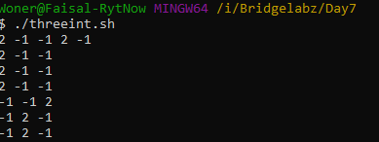



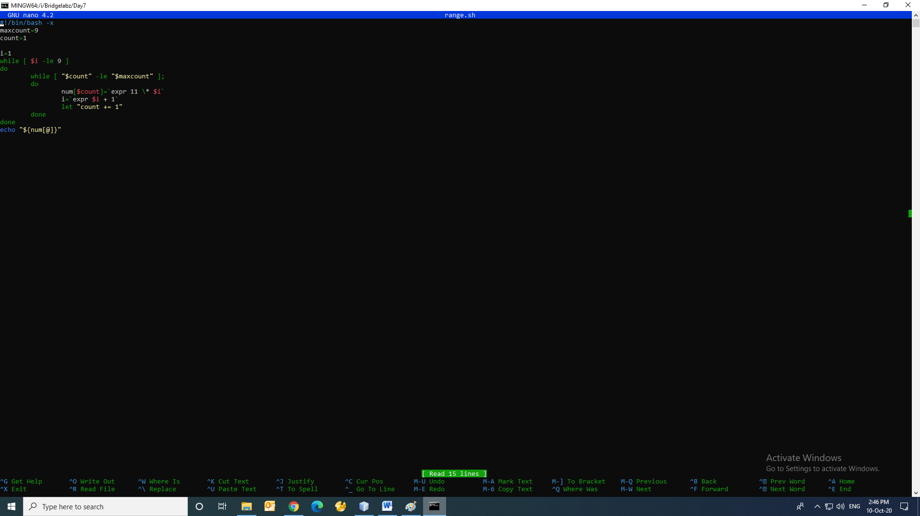

**EXECUTION—**

